# How to setup the Presence Sensor

The LD2410 is a sensor that has two outputs: the first one is a digital signal that high when there is a person within the zone of detection. The second signal is a serial signal that outputs information about the distance of the target. To record a person the sensor is using a 24 GHz low powered microwave signal. A person does not have to move to be detected so this sensor offers different possibilities than the regular PIR sensor that rely on infrared and motion.

In the following chapters we will go thru the process two different process of setting up the presence sensor: 1) starting from scratch where you flash the Presence Sensor with Tasmota. 2) starting with a pre-installed device that has Tasmota pre-loaded (Link). In both case you will configure Tasmota so the unit connects to your network, you will configure setting within Tasmota to make sure the sensors an MQTT signal to Home Assistant, and you will setup Home Assistant so that the sensors and switches show their information properly.

Table of Contents

How to setup the Presence Sensor 1

Prerequisites 2

Home Assistant 2

MQTT Broker 2

Tasmota 2

The process starting from scratch 3

Download the Tasmota.Bin file 3

Flashing the ESP8266 4

Configuring the switches in Tasmota 7

Starting with a pre-installed device 10

Home Assistant 22

Issues 25

Other issues 25

Extra Information 25

# Prerequisites

## Home Assistant

Home Assistant (HA) runs on different platforms and can be installed in different ways. For more information visit the [Home Assistant Webpage](https://www.home-assistant.io/installation/). For detailed instructions how to setup both HA and the MQTT broker follow [this link.](https://haprofs.com/setting-up-mqtt-mosquitto-broker-home-assistant/)

## MQTT Broker

In HA make sure the MQTT broker is installed and running.

Create an extra account with a password that you can later use for your upcoming Tasmota device.

[Link to Home Assistant how to install MQTT](https://www.home-assistant.io/integrations/mqtt/)

## Tasmota

Tasmota is the software that runs on the Presence Sensor and a plug in for HA will be needed. Tasmota depends on an MQTT broker. As that should now be running, continue with the setup of Tasmota within HA.

[Link to Home Assistant how to install Tasmota](https://www.home-assistant.io/integrations/tasmota/)

# The process starting from scratch

The processor in this project that communicates the sensor data over WiFi to Home Assistant is called an ESP8266. It is assembled on a little development board called a Wemos D1 Mini. This board takes care of the 5-volt from the USB port to 3.3-volt needed by the EPS8266 as well does it take care of the communication coming from the PC via the USB port to the ESP8266 so that we can flash and configure it. We will flash the ESP with Tasmota (Freeware) and to do this we use Tasmotizer (Freeware). After flashing Tasmota to the ESP8266 we will configure Tasmota and connect it to the MQTT broker and set it up in HA.

## Download the Tasmota.Bin file

The software for the ESP8266 that we need, comes in a BIN file which is stored on a GitHub page. Download the Bin file named “**Tasmota13-LD2410-only.bin**”. Visit the GitHub page where the BIN file is stored.

<https://github.com/Roukie686868/Presence-Sensor/tree/main/BIN>

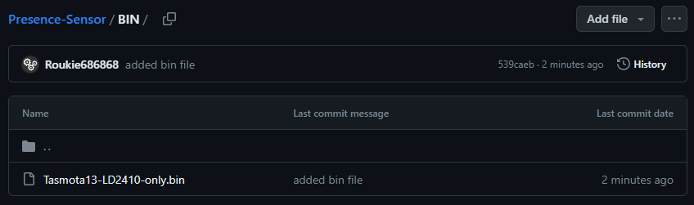

Click the on filename so that it opens, giving you the following view

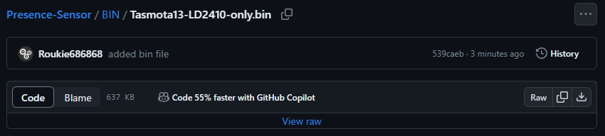

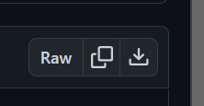Now click on the download icon. You find this all the way to the right of the screen. This is the one where the arrow points downwards into the tray.

The file will download and you should be able to find it in your download folder under your documents (for Windows machines). Next, we need a tool to flash this BIN file to the ESP8266.

## Flashing the ESP8266

The tool we will use to flash the ESP8266 is “Tasmotizer”. It was written to flash Tasmota to an ESP8266 and also allows to configure some initial network and MQTT setting to the ESP8266 after flashing. Via the next link you can download Tasmotizer. Click <https://github.com/tasmota/tasmotizer/releases> and download “**tasmotizer-1.2.exe**” by clicking on the file. (For older PC with a 32-bit system there is the tasmotizer_x86-1.2.exe”)

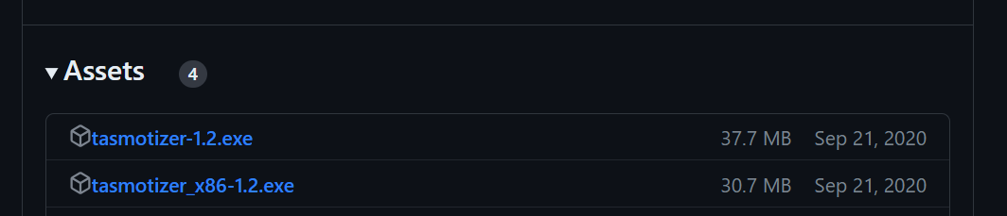

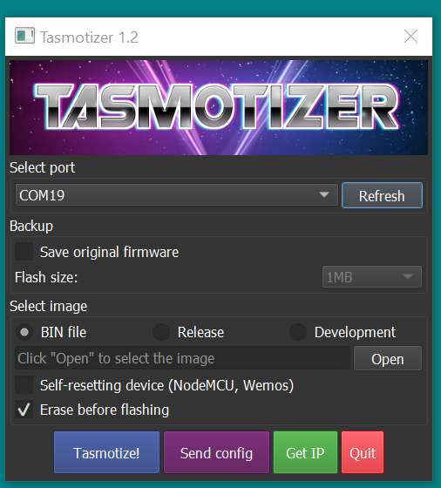The download should start automatically and the file ends up in your download folder under your documents. Go to your download folder and double click the file so that Tasmotizer starts. First thing to do is to find out which COM: port the PC will give to the ESP8266. Click on the dropdown arrow to see which ports are there. Now connect the ESP8266 to your PC via a USB cable (make sure to use the little Micro USB connector on the inside of the box and not the big USB port on the outside), click “Refresh” and see which COM: port appeared new. Now select the new port. (Be careful!!! Verify your Com: port: when you have multiple EPS8266 units connected to your PC, you don’t want to make the mistake of wiping/flashing the wrong unit.)

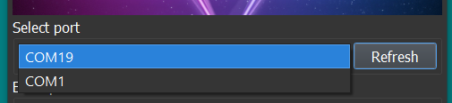

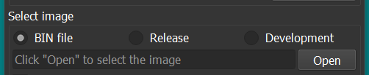Now that you verified you have the correct COM: port you need to select the BIN file that you downloaded earlier from the GitHub page. Under “Select image” pick “BIN file”. Now click on the “Open” button to select the BIN file that you downloaded.

Find your file in the download folder, select it and click “Open”

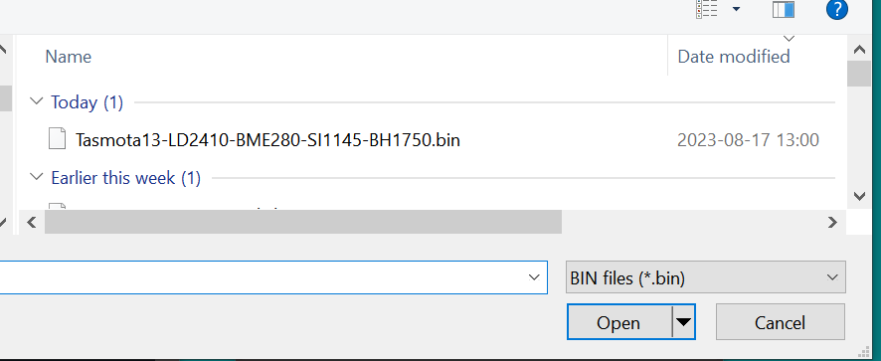

The Tasmota screen should look like the next screenshot

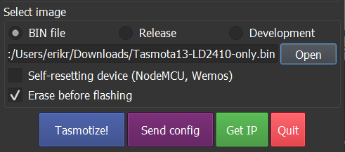

Verify that the “Erase before flashing” is marked. (This is to make sure older settings are wiped from the ESP8266).

To be able to flash the new software you will have to either remove the 2 jumpers in the middle of the board OR take the ESP8266 out of the board. Either method disconnects the ESP8266 from the LD2410 sensor. The sensor uses the same serial port that we need for flashing. At the end of the process replace the jumpers or the ESP8266.

Now click the blue “Tasmotize!” button to flash the ESP8266.

Tasmotizer will first Erase the content of the ESP8266.

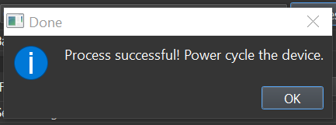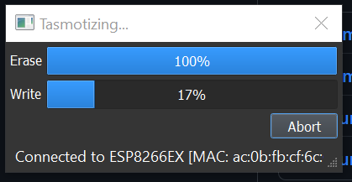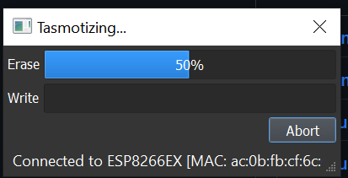Then it will flash the BIN file to the EPS8266.

When the process is successful the last popup will appear telling all worked well. Now Click “OK”. (With the WEMOS ESP8266 there is typically no need to power cycle.)

Now it is time to setup the Network and MQTT configurations. Click the purple “Send config” button.

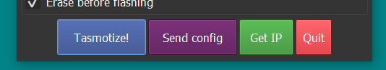

The following configuration menu shows up.

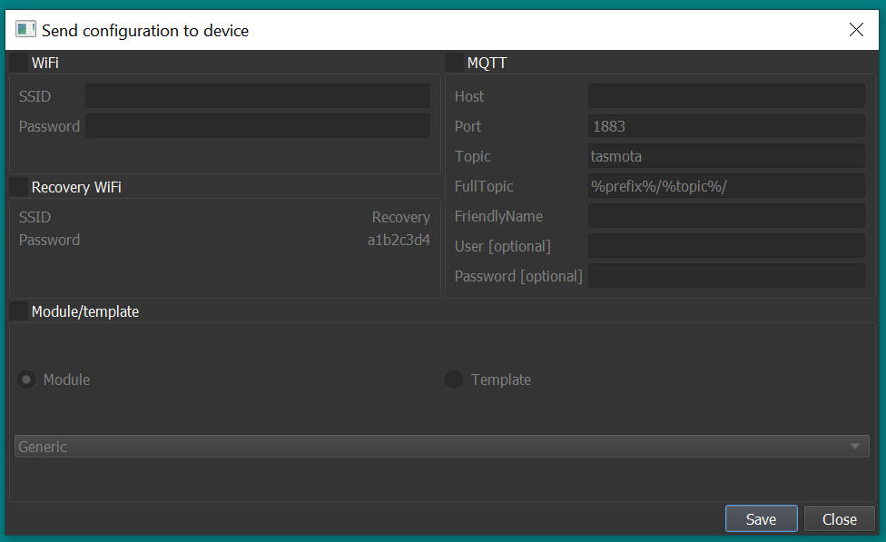

Enable the “WiFi” and “MQTT” boxes so that we can fill in the needed information.

WiFi

* Type your Network name and password in the two fields under WiFi.
* As the password will not be visible it makes sense to first type it in Notepad and then copy and paste it over to Tasmotizer. This to make sure that are no Typos.

MQTT

* HOST - Point to your MQTT server by listing the IP address of the MQTT server (Typically an address like 192.168.1.x) When your MQTT broker is installed via HA than it will be the same address as HA is using.
* Port – Standard is 1883 but if you have chosen a different number list it here
* Topic – Give a name you like the unit to be called or simply start with “tasmota”. (We can change that later)
* FullTopic – Make sure to not delete anything out of this line. (The prefix and topic are used by Tasmota to communicate with MQTT) (%prefix%/%topic%/)
* FriendlyName - Typically this is the same as the Topic to keep things easy (Again we can all change this later within the Tasmota Webpage)
* User – When you used credentials for the MQTT server than list the username here
* Password - When you used credentials for the MQTT server than list the password here (maybe here as well type it first in a Notepad and copy it over)

Enable the Module/template box

* Select “Template” and copy the line below into the textbox

**{"NAME":"Presence Sensor","GPIO":[0,9248,0,9280,0,0,0,0,0,0,160,0,0,0],"FLAG":0,"BASE":18}**

This will setup Tasmota with the correct inputs for the sensors.

An example of that below.

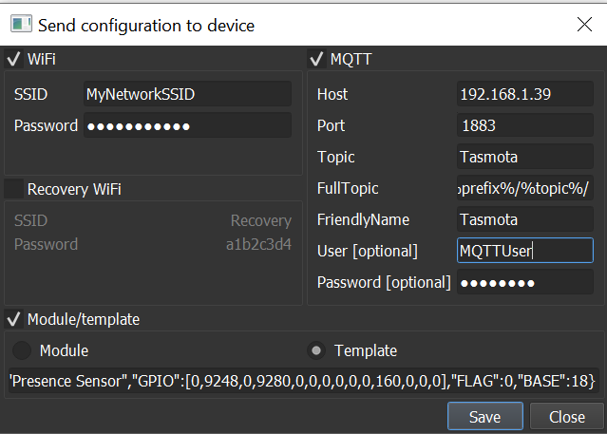

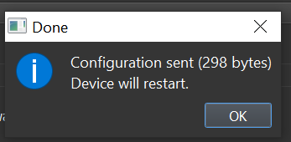Now click the save button. Tasmotizer will now write your information to the Tasmota software on the ESP8266. Depending the amount of data, the number of bytes will change displayed in the popup.

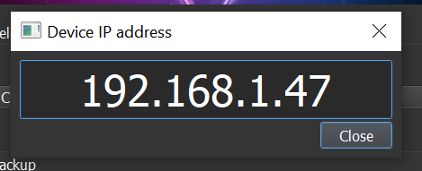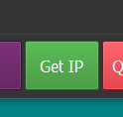Wait about 30 second and click on the Get IP” button. When all went well there should be an IP address listed that we can visit in a browser.

If the IP address shows as xxx.xxx.xxx.xxx then head over to **“****Home Assistant****”** section to get to the unit. We will come backat this point to configuring the switches in Tasmota.

## Configuring the switches in Tasmota

Open up a web browser and go to the IP address that was listed in your popup.

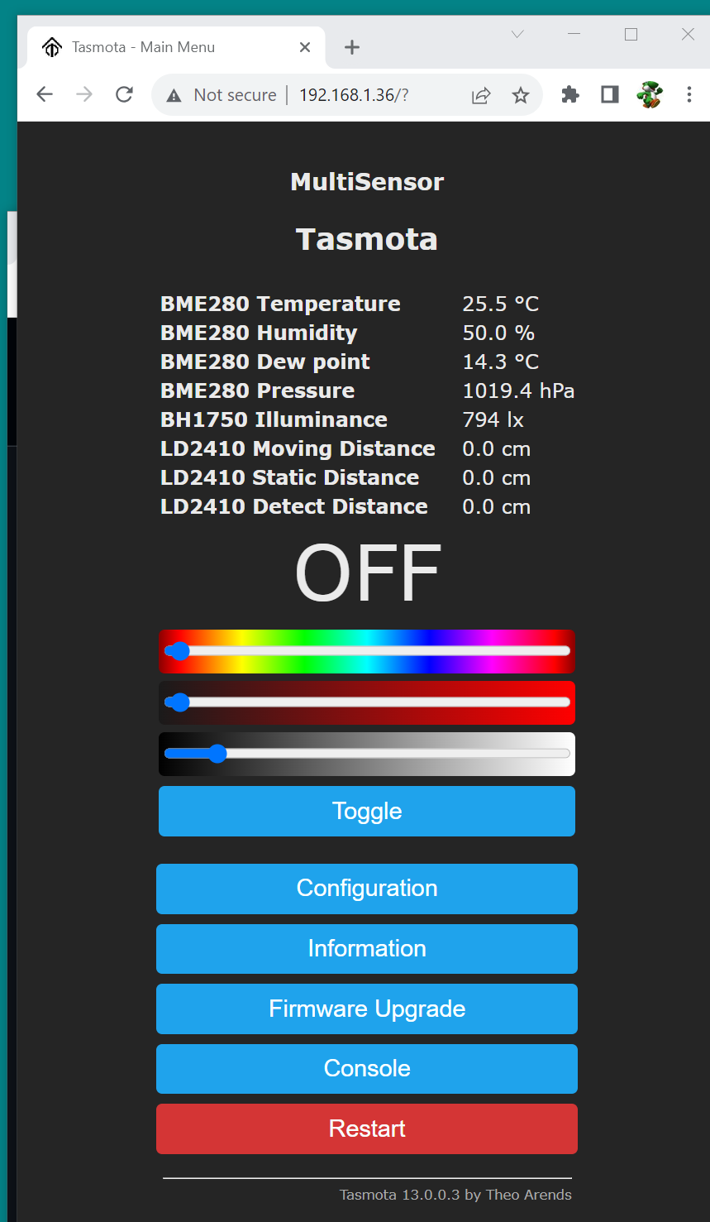

When all was installed properly a similar view as above is what you should see. Depending what sensor units that are installed on the MultiSensor board different measurements will show up. As the LD2410 uses a serial protocol it will always show on the screen even when it is not there. As Tasmota does not transmit the data for the HLK-LD2410 when it is not there, we will not see this info in HA. The HLK-LD2410 and the RCWL-0516 share the same space on the PCB. When the RCWL-0516 is removed the more expensive HLK-LD2410 can be placed later.

Now let’s click on the “Console” button. The console screen will show you what is happening within the unit but it also allows for making modifications to the Tasmota settings. On the command bar enter 7 different commands printed below in **BOLD:**

**SwitchMode 15** // This command lets the switch (The PIR) send MQTT messages

**SetOption114 1** // This command decouples the switches from relays

**SwitchText1 mmWave** // This tells Home Assistant the name of the switch

**DeviceName tasmota** // Label this equal to your MQTT Topic name

If you want to read up on these Tasmota settings they can be found on the following Tasmota webpages:

<https://tasmota.github.io/docs/Buttons-and-Switches/#setoption114>

<https://tasmota.github.io/docs/Buttons-and-Switches/#switchmode-15>

To make sure HA sees the new setting give the following two commands

**SO19 1**  // This disables the Tasmota unit in HA

**SO19 0**  // This turns the Tasmota unit back on in HA

# Starting with a pre-installed device

When your device was pre-loaded with Tasmota the configuration will go a bit different.

## Connect to the ESP8266

You will have to make a WiFi connection with the ESP8266 via either a mobile phone, tablet or a laptop. Find a network that looks like Tasmota-XXXXXX-YYYY and connect to it.

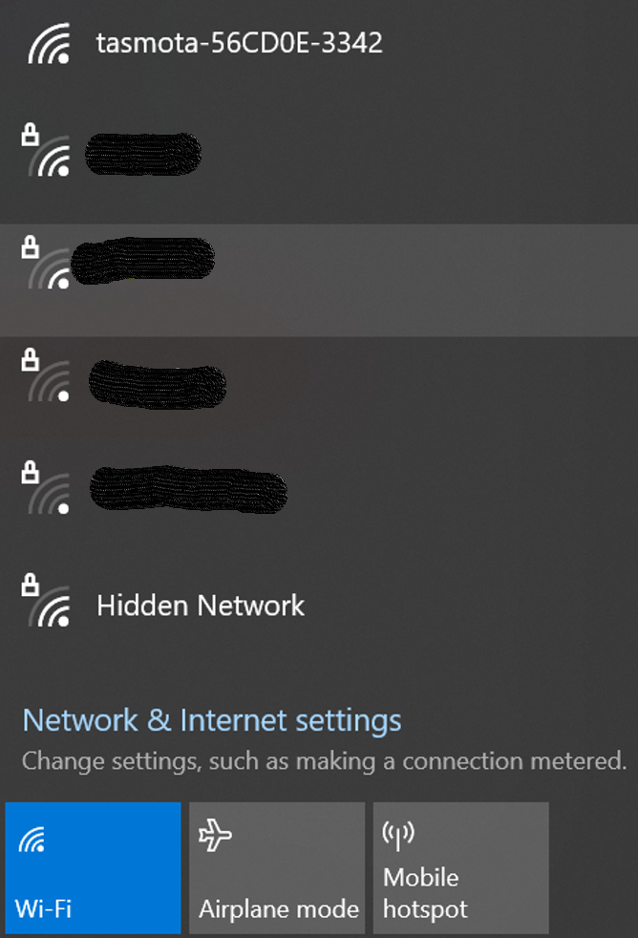

Within 30 seconds after connecting a webpage should open where the WiFi setting can be entered. If it does not open up, use a web browser and go to the address 192.168.4.1

A similar screen as seen in the next screenshot should open.

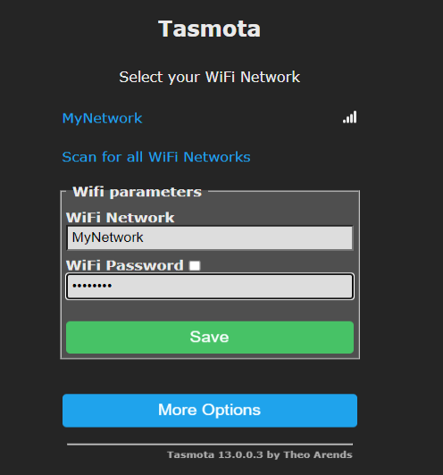Select your own network from the list or type is straight in the top box. In the Bottom box you will have to list the network password.

Then click “Save”

The device will now try to connect to your network.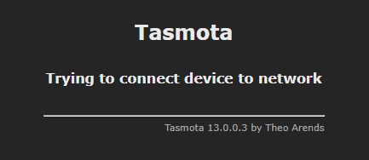

When connect correctly, it will list its new IP address on your network. This might take up to 1 minutes.

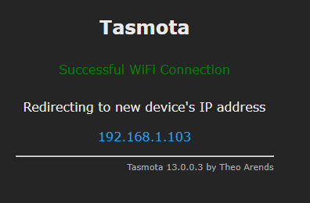

Now switch back your normal network and visit the device at the new network IP address.

## Setting up the inputs

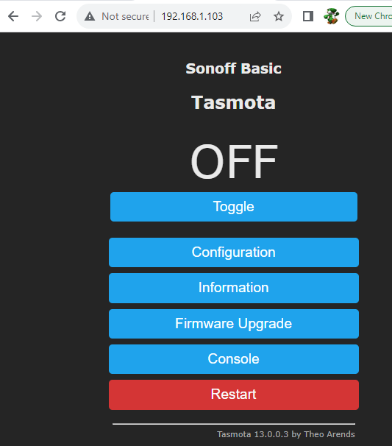

Now select the “Configuration” option.

Next select “Configure Module”

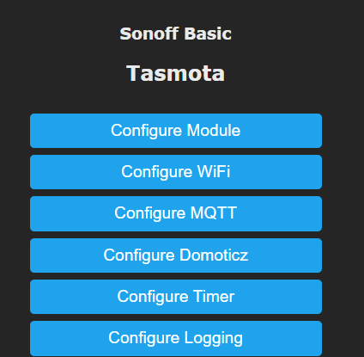

Next select the “Generic (18)” model and click save.

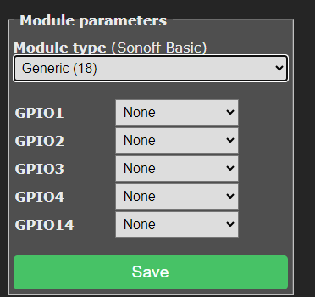 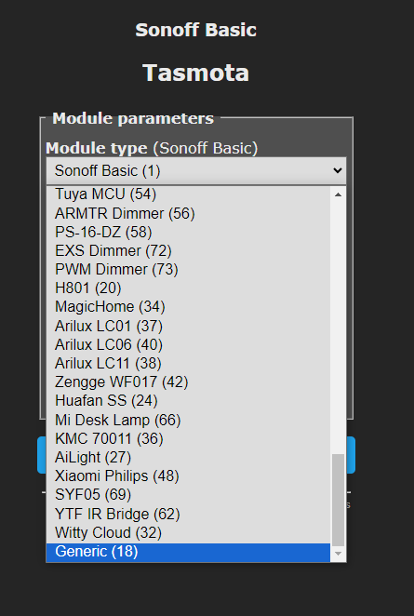

Wait about 10 to 20 second and the screen should be at the start screen again.

Click “Configuration” next click “Module” and make the following settings:

TX GPIO1 to “**LD2410 Tx”**

RX GPIO3 to “**LD2410Rx**”

D5 GPIO14 to “**Switch” “1**”

Your screen should look like what you see in the next screen shot. 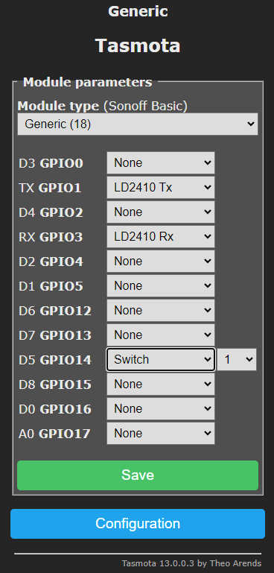

Now click “Save”. Wait again 10 to 20 seconds for the screen to return to the start page. When all was installed well you should see something like the next screenshot. 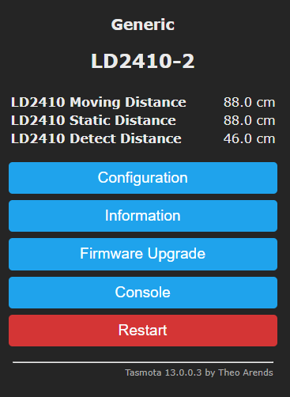

Next part to setup is the MQTT broker

## Configuring MQTT

Click “Configure” and now select “Configure MQTT” 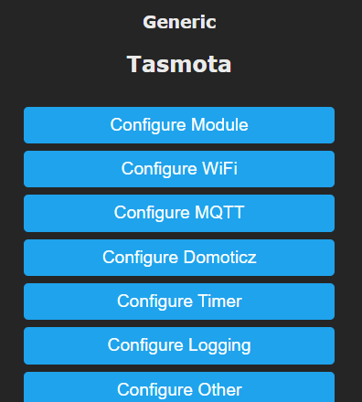

List the MQTT host address. If your MQTT broker is part of Home Assistant then the address will be the same as the Home Assistant IP address. When you use a standalone MQTT Broker list its address.

The standard Port number for non-secured trafic is 1883.

Under User list the Username that you have setup in the MQTT broker

And under Password list the password that goes with your username

For the Topic just list the name that you like to give to your device. For the example we will use “tasmota”

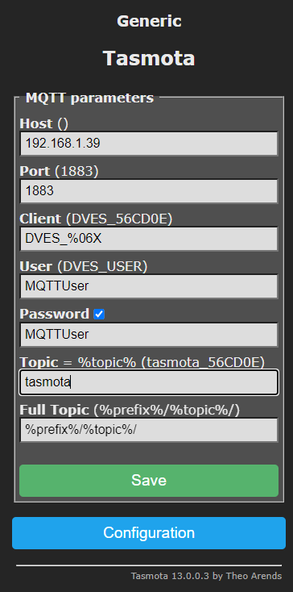

Click “save” and wait 10 to 20 seconds for the start screen to show up again.

## Setting up Tasmota

Now click the “Console” button.

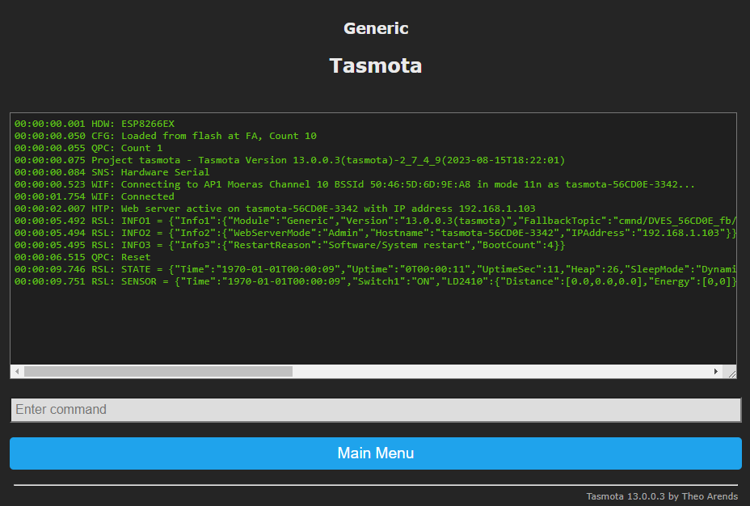

In the bar that says “Enter command” you will need to enter a few commands to make the sensor work properly in Homa Assistant

Type only the bold text in the command line:

**SwitchMode 15** // This command forces the unit to send MQTT updates

**SetOption114 1** // SetOption114 1 detaches output signals from input signals for more info visit

// <https://tasmota.github.io/docs/Buttons-and-Switches/#setoption114>

**SwitchText1 mmWave** // This tells Home Assistant the name of the digital switch. Feel free to use a // different name

To trigger Home Assistant to see these new setting we will disable the unit in HA and enable it again with the following to commands

**SetOption19 1** // This disables the unit in HA

**SetOprion19 0**  // This enables the unit in HA

Now go over to Home Assistant and click “Setting” in the left bottom, then “Devices & services” followed by the clicking on the blue line listing a number of Tasmota devices 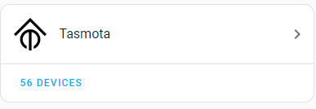

In the screen shot below you can see that Line 4 is the new device that was added. Click on its name and to get the details screen.

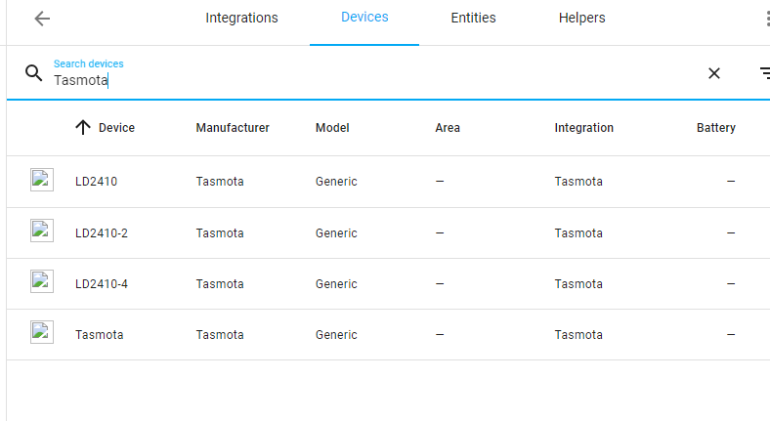

# Home Assistant

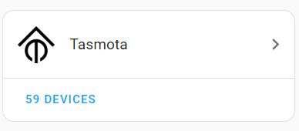Both **MQTT** and **Tasmota** have to be install within Home Assistant. If not do so first. When installed the Device can be found by:

* Click on “Settings” (left bottom corner of the screen)
* Click on “Devices & Services”
* Select the blue “DEVICES” under the Tasmota Icon
* In the list, the device should show up as **“Tasmota”** (or any other name that you use in “Tasmotizer” when sending over the configuration file.
* Click on “Tasmota”

Now a device screen shows up as seen in the next picture. If you had issues with the IP address of the device, click on the blue “Visit” icon in the “Device Info” section to go to the device and make the settings you were not able to do in the previous chapter. When the Tasmota settings are done come back at this point and continue.

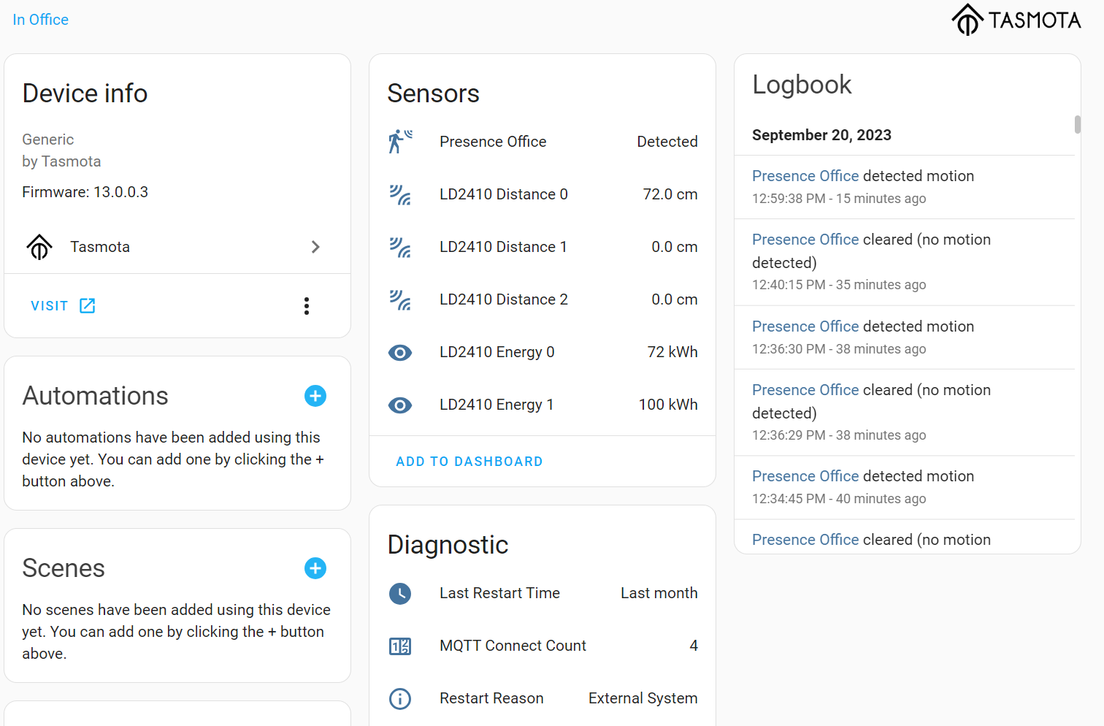

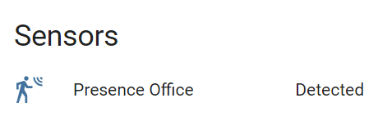Now let’s change the Icon and the text that the sensor displays to something that is more meaningful. See the image right. Click on the “mmWave” text so that the popup shows as seen in the next image. (If you do not see mmWave skip ahead to the issues section to resolve this)

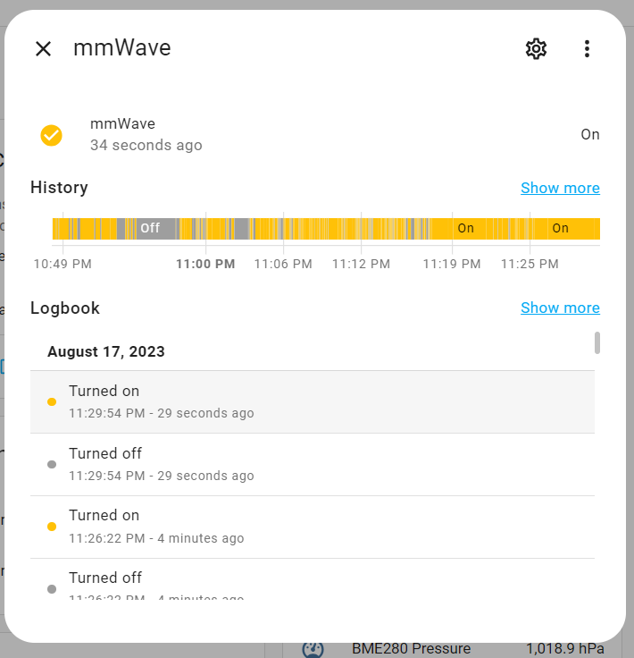

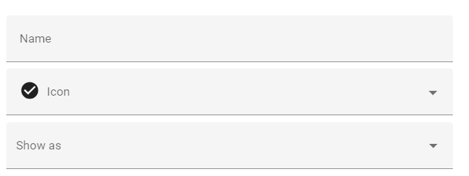Now click on the little star wheel in the top. In the next popup we are going to change the “Icon” and the “Show as” field.

Click right on “Icon” and type the word “motion” in the Icon field (typing “Presence” could be another option) and pick the symbol that you like for this sensor.

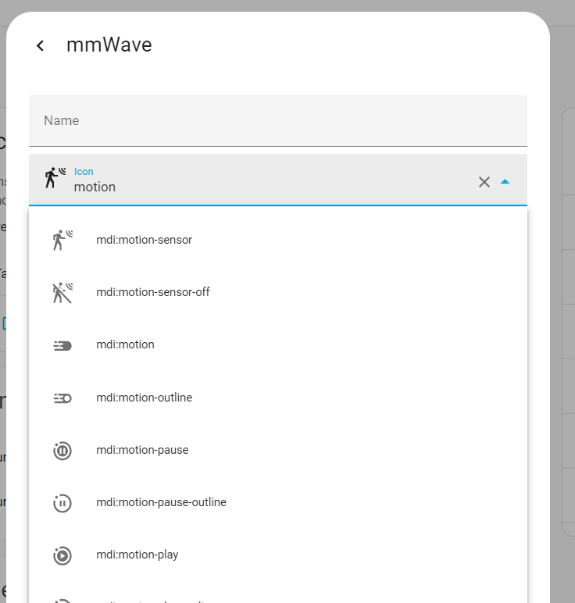

Now click on “Show as” and type motion again (typing “Presence” could be another option)

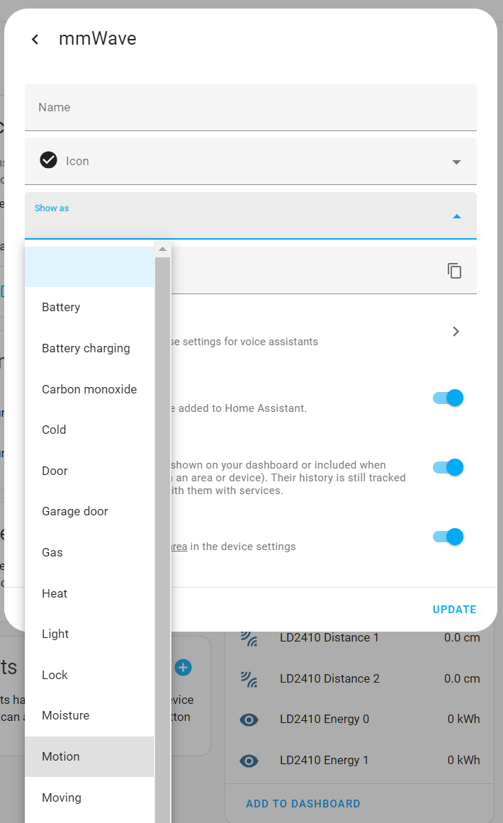

In the right bottom of the popup click on “UPDATE” to make sure your settings are saved.

Below you can see what your changes have accomplished. Repeat the same for the PIR sensor.

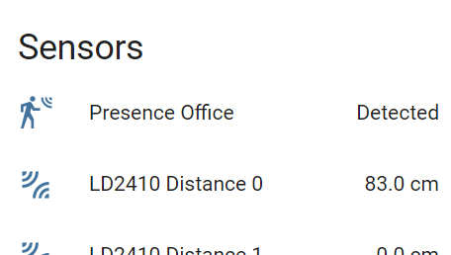

Congratulations. You are ready to further integrate your sensor into you Home Assistance system.

# Issues

* When the switch does not show a reading but says “**unknown**”
  + Go back to the Tasmota console and change the **SwitchText** for a low case text. Follow this by a **SetOption19 1** to turn the device off in Home Assistant and turn in back on again with **SetOption19 0**. This should reset HA.

# Other issues

When you still can’t resolve an issue, contact me on the following discord channel.

<https://discord.gg/D4hMt9rzSx>

# Extra Information

More details on the project can be found on the following GitHub Page <https://github.com/Roukie686868/Presence-Sensor/>